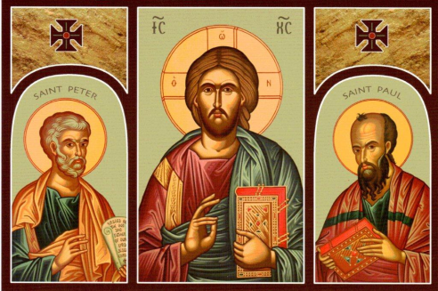



**St. Patrick’s R.C. Church**

Glenfield Road, Fairfield,

Stockton-on-Tees, TS19 7PJ

**Parish Priest : Fr. John Cooper**

**Tel. 01642 674321**

E-mail : stpatricks.fairfield@btinternet.com



He is Risen

**Sunday 28th June 2020**

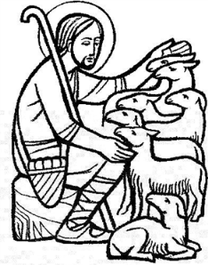

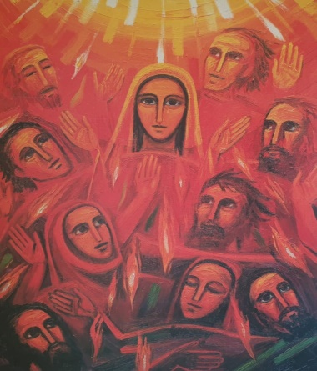

This Sunday, the Church celebrates the solemnity of Saints Peter and Paul. Together, these two saints are the founders of the See of Rome, through their preaching, ministry and martyrdom. Yet despite his human weaknesses, Peter was chosen to shepherd the Lord's flock. The Acts of the Apostles illustrates his role as head of the Church after the Resurrection and Ascension of Jesus. Peter led the Apostles as the first Pope and sustained the unity of the apostles.

St. Peter spent his last years in Rome, leading the Church through persecution and eventually being martyred in the year 64. He was crucified upside-down at his own request, because he claimed he was not worthy to die as his Lord. He was buried on the Vatican hill, and St. Peter's Basilica was built over his tomb.

St. Paul was the Apostle of the Gentiles, and his letters teach us much about his life and the faith of the early Church. He was imprisoned and taken to Rome, where he was beheaded in the year 67. He is buried in the Basilica of St. Paul’s Outside-the-Walls in Rome.

St. Augustine of Hippo wrote of these two saints: “Both apostles share the same feast day, for these two were one; and even though they suffered on different days, they were as one. Peter went first, and Paul followed. And so we celebrate this day made holy for us by the apostles' blood. Let us embrace what they believed, their life, their labours, their sufferings, their preaching and their confession of faith.”

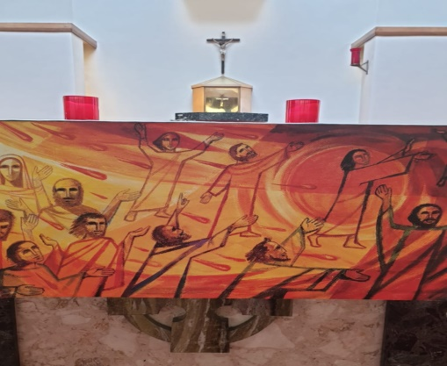



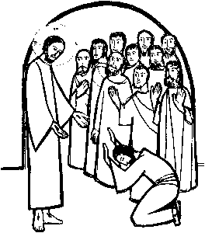

**The Peter’s Pence Collection** is a gesture of solidarity. Through it, every member of the faithful can participate in the Pope’s activity. It is an activity that supports the most needy and ecclesial communities in difficulty who approach the Apostolic See for help. On 29th April 2020, the Director of the Holy See Press Office, Matteo Bruni, announced that: “Considering the current health emergency, the Holy Father has established that, for the current year 2020, the Peter’s Pence collection, which traditionally takes place around the solemnity of Saints Peter and Paul on 29th June, will be transferred throughout the world to the 27th Sunday of Ordinary Time, 4th October, memorial of Saint Francis of Assisi”.

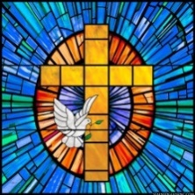



**Prayer for Pope Francis . . .** *O God, shepherd and ruler of all the faithful, look favourably on your servant Francis, whom you have set at the head of your Church as her shepherd; Grant, we pray, that by word and example he may be of service to those over whom he presides so that, together with the flock entrusted to his care, he may come to everlasting life. Amen.*

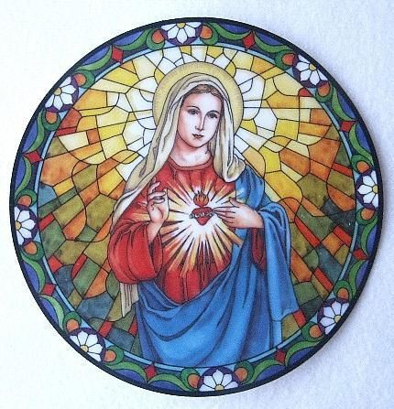

|  |  |  |  |
| --- | --- | --- | --- |
| thumbnail_Resized_20200621_121242[2]***Masses with no Congregation****949990[1]*  He is Risen  [Eucharist Clipart | Free download on ClipArtMag](about:blank)    Your light is the only light we need as we travel through life's mystery. Your word the only voice we hear that still small voice that leads us to the place where we should be. Your presence is the only company we need as we walk this narrow road, Your fellowship the warmth we crave to help us on our way. May the truth of Easter. the joy and the blessings of Easter be with us this day and all days. Amen  *949990[1]*  **SS PETER & PAUL** | | | |
| 28 | Sunday |  | People of our Parish |
| 29 | Monday |  | thumbnail_Resized_20200621_121242[1]Dickinson & Thomas  Families |
| 30 | Tuesday |  |  |
| 1 | Wednesday |  |  |
| 2 | Thursday |  |  |
| 3 | Friday  ***St Thomas*** |  |  |
| 4 | Saturday |  | Eileen Lyons |
| **14th SUNDAY OF THE YEAR** | | | |
| 5 | Sunday |  | People of our Parish  Jesus, each time I look at the sacred Host, send a ray of divine light into my soul, that I may better know you and myself. Amen. |
| **Anniversaries:** | | Mary Tunney, Margaret Sisson, Jill Bradley | |
|  | | Riska Okninski, Monica McShane, Billy McGuinness, Pat Jackson, Margaret Devlin, Pauline Morton, Mike Rutland, Margaret Kenning, Christopher Brown,  Fr. Pat McKenna, Rosie Owens, Andrew Brydon, Mary Talbot, Veronica Connors, Betty Griffiths, Sadie Todd. Audrey Bentley | |

**THIS SUNDAY’S READINGS . . .**

* **First Reading ~ Acts 12:1-11**
* **Responsorial Psalm ~ Psalm 33:2-9**
* **Second Reading ~ 2 Timothy 4:6-8, 17-18**
* **Gospel ~ Matthew 16:13-19**

*We pray for all those preparing our churches for the resumption of Masses, that they may be guided by the Spirit to ensure a spiritual and safe homecoming for all the faithful.*

*We pray that the God of glory may make his light shine in our church community as he works among us and blesses us with his presence.*

*We pray for all bishops, priests and deacons, that they may be propelled by Christ’s commandment of love and service to all in their vocations.*

**The God who Speaks Prayer**

Living God, you walk alongside us and speak to us throughout the Scriptures. Your Son, Jesus Christ, listens to our hopes and fears and shows us how to live for one another. Send us the Holy Spirit to open our hearts and minds so that we may be your witnesses throughout the world. Amen.

**Mass is celebrated on a Thursday at 7pm** for the sick, their families, Care Workers and NHS Staff. This Thursday, 2nd July, Mass is from St. George’s Cathedral, Southwark. Please visit www.cbcew.org.uk to access the Mass.

**Make an Online Virtual Pilgrimage . . .** FaithND invites you to explore the Holy Land virtually as a way to enhance your reading of [the daily Gospel](about:blank)and come to know Jesus more deeply. Here, you can encounter the Holy Land through pieces of reflection and meditation, photos and videos. You can learn more about the spaces in the Holy Land—the geographical markers, the landscapes, and the town and villages—in which the Gospel accounts take place. You can see images of the churches which stand over the spots where important events in the life of Christ and the Church took place. To view please enter into your search engine: Virtualpilgrimage – faithND

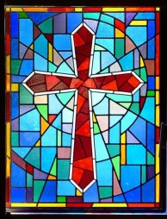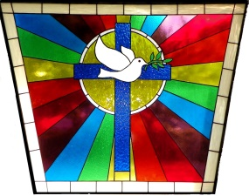**CELEBRATE ONLINE CONFERENCE . . .**  We feel, in the midst of uncertain circumstances, God is giving us an opportunity to connect in different ways. This is why we are delighted to announce our first ever, free, ONLINE CONFERENCE! You can take part in as little or as much as you’d like, whether it’s for an hour or you want to use the whole weekend to retreat. Over the weekend we’ll be releasing everything at specific times but you can replay all our content at any point if you missed it or want to watch again. Here is the **full schedule**:

**SATURDAY**

**10am**  Listen: A talk from our first keynote speaker

**12Noon** Pray: A Guided Prayer session

**3pm** Do: Children's 'Messy Church' + various workshops

**5pm** Live Worship

**6pm** An Evening In with CELEBRATE

**9pm** Night Prayer

**SUNDAY**

**10am** Listen: Our second keynote speaker

**12Noon** Pray: Mass with Bishop David Oakley

**3pm** Do: Interactive Family Prayer

**4pm** Final session

**Update on Re-opening of Churches . . . Thank you to our volunteers** who are waiting news as to when they can swing into action to clean and prepare St Patrick’s for re-opening. The diocese will provide each parish with the materials needed to safely prepare church and deciding the order in which parishes are to re-open, this will include a Health and safety check. Please see the **updated Handbook** re-opening of Churches attached. Also find attached a letter from the Metropolitan Archbishops in England regarding the resumption of Public Worship. (Deacon Mick)

***Pope Francis’ Prayer to the Virgin for Protection***

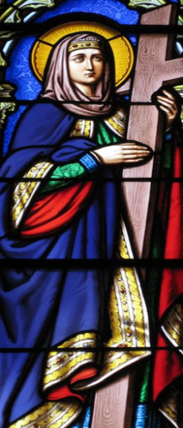

O Mary, you shine continuously on our journey as a sign of salvation and hope. We entrust ourselves to you, Health of the Sick. At the foot of the Cross you participated in Jesus’ pain, with steadfast faith. You, Salvation of the Roman People, know what we need. We are certain that you will provide, so that, as you did at Cana of Galilee, joy and feasting might return after this moment of trial. Help us, Mother of Divine Love, to conform ourselves to the Father’s will and to do what Jesus tells us: He who took our sufferings upon Himself, and bore our sorrows to bring us, through the Cross, to the joy of the Resurrection. We seek refuge under your protection, O Holy Mother of God. Do not despise our pleas, we who are put to the test, and deliver us from every danger, O glorious and blessed Virgin. Amen.

**ST PATRICK’S PARISH LOCKDOWN EVENT Phone a Parishioner Day**

Following a suggestion we will be holding a St Patrick’s “Phone a Parishioner Day.” this coming **Wednesday 24th June**. Please look in your address book for parishioner/parishioners you haven’t spoken to for a while. Pick up the phone and give them a call to say “Hi” or “how are you keeping in lockdown” Hopefully this initiative will ignite many conversations across our parish family and reach those who do, and don’t, receive the bulletin. On Wednesday please take five minutes to phone a parishioner /parishioners you never know what your call might mean to that other person. Or what it might do for you. Nothing can replace the sound of a friendly voice at the other end of the line. Any feedback from the day would be most welcome.

*You have blessed us, O God, with the gift of friendship, the bonding of persons in a circle of love. We thank you for such a blessing: for friends who love us, who share our sorrows, who laugh with us in celebration, who bear our pain, who need us as we need them, who weep as we weep, who hold us when words fail, and who give us the freedom to be ourselves. Bless our friends with health, wholeness, life, and love. Amen.*

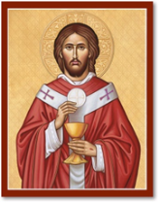**St. Mary’s Cathedral, Newcastle upon Tyne** is now open daily from 1.00pm – 4.00pm (including Saturday and Sunday) plus 9.30am – 11.15am on Saturday and Sunday only.



**Parish Event – Phone a Parishioner Day . . . A Big Thank You** to everybody who took time on Wednesday to contact St Patrick’s parishioners to say **“Hi”** or **“how are you keeping in lockdown.”** The feedback received suggests many conversations were ignited across our parish reaching many people. The fire at the heart of our parish ‘God’s love’ was burning brightly across our parish family. Thank you, for all you do and continue to do supporting and providing each other with prayers, phone calls and where possible practical support. Any suggestions for future ‘Parish Events’ are welcome.

**THANK YOU** to all St. Patrick’s parishioners who are delivering bulletins, providing treats and for all other acts of kindness during these difficult times.

**Please forward any prayers**, thoughts, poems, news, anniversaries or any item that you would like to share and I will include them on the bulletin. Thank you.

**Please could you pass this newsletter round the parish** by forwarding to your parish contacts.  If you do not wish to receive future newsletters please email [stockton.stpatrick@rcdhn.org.uk](about:blank) or [stpatricks.fairfield@btinternet.com](about:blank) to be removed from the mailing list. If you know of any parishioner who would like to start receiving the bulletin please ask them to e-mail the above. This bulletin can also be accessed through the Parish Family Stockton website: www.parishfamilystockton.org.uk.